Mechanical Services & Design, Inc. & EMS Partnership

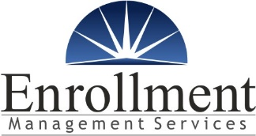
Kristin Croweak is our EMS Resource Specialist.
Feel free to call or contact her directly at:
(513) 878-2390 or email her at mpleasant@enrollmentmanagementservices.com | (513) 878-2390 or email her at mpleasant@enrollmentmanagementservices.com

(513) 924-4579 kristin@enrollmentmanagementservices.com
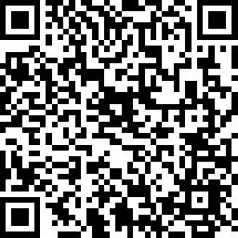
If you haven’t connected with EMS in the past, we’d invite you to complete a short intro survey by scanning the QR Code below. This survey will review the basics of EMS Support and can help identify if there are any opportunities for EMS to help you or your family.

EMS Support
MSD, Inc. is committed to providing a comprehensive and affordable health plan for all our employees. We have worked hard to maintain our health plan, but we also recognize that some employees may have other insurance options available based on their unique situations. To better support the insurance options of all employees, we have partnered with the healthcare consulting team of Enrollment Management Services (EMS).
Whether an employee enrolls with our group plan or identifies another outside resource, we believe everyone benefits by understanding all their options. The EMS team is available to help our employees throughout the year. If you experience certain life events (new hire, termination, increased utilization, FMLA, etc.), EMS will proactively reach out and see if there is anything they can do to help. As a reminder, any interaction with EMS is private and protected under HIPAA. No protected health information (PHI) is shared back with MSD, Inc. or HR.
Opt-Out Benefit Credits
Benefit credits may also be available for employees who waive healthcare coverage for themselves and/or dependents because they are insured through an insurance option outside the MECHANICAL SYSTEMS OF DAYTON Group Plan. In this way, employees have financial support to take advantage of whatever insurance option works best for their unique situation.
You may qualify if you have any of the following available:
• Coverage through your spouse
• Medicare, Medicaid, or SCHIP
• VA or Retiree Plan, Individual Plans, or other

If you are interested in learning more about the Opt-Out Program or any insurance options you may have available, please reach out to the EMS team for support.

